**Active Collab**

**Setting up a project**

For every project you need to create a project number in Active Collab.

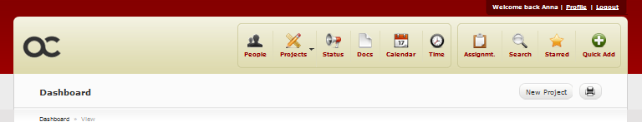

1. Go to ‘new project’
2. Add in your name and the client in the drop down menus at the side

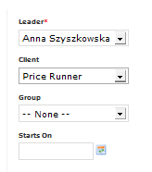

1. In the name section follow the usual convention (these will alter slightly, dependant on the sort of job it is)
2. i.e. pr_pxxxx_name

You can have a look in the project folder for the relevant client to see how they are named.

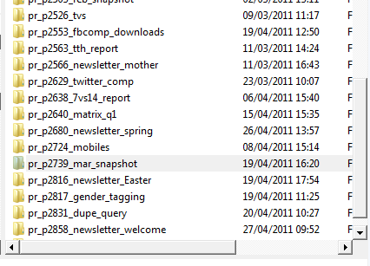

1. You will not know the reference number when you create the project so leave this blank. You will then be given a unique number. Find this out by moving the mouse over the project reference at the top, which will show the new project number at the bottom of the window.



1. When you click on this you will be taken to an overview page.

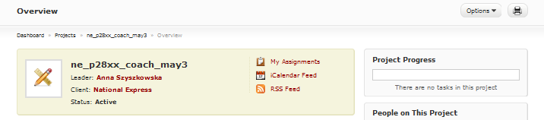

1. Click on options, then edit in the drop down menu.
2. Type in the correct number, then press submit

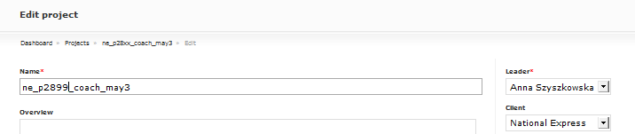

1. You will then be shown an overview page with your newly created project

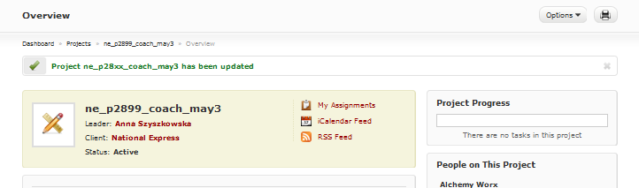

Once you have done this, you will need to create a new project folder with this newly created project number.

e.g.:

In 2011 > in the relevant client folder > at the bottom of the current list.

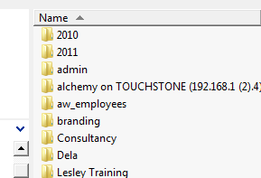 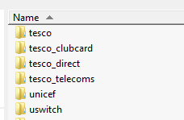 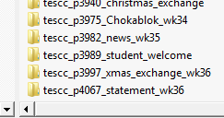

In the new folder create subfolders for assets, data, design and html

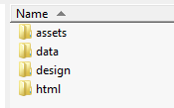

You are then ready to put all the relevant assets/information in the folders and start the job.